**Case (i) : Distance < 100cm**

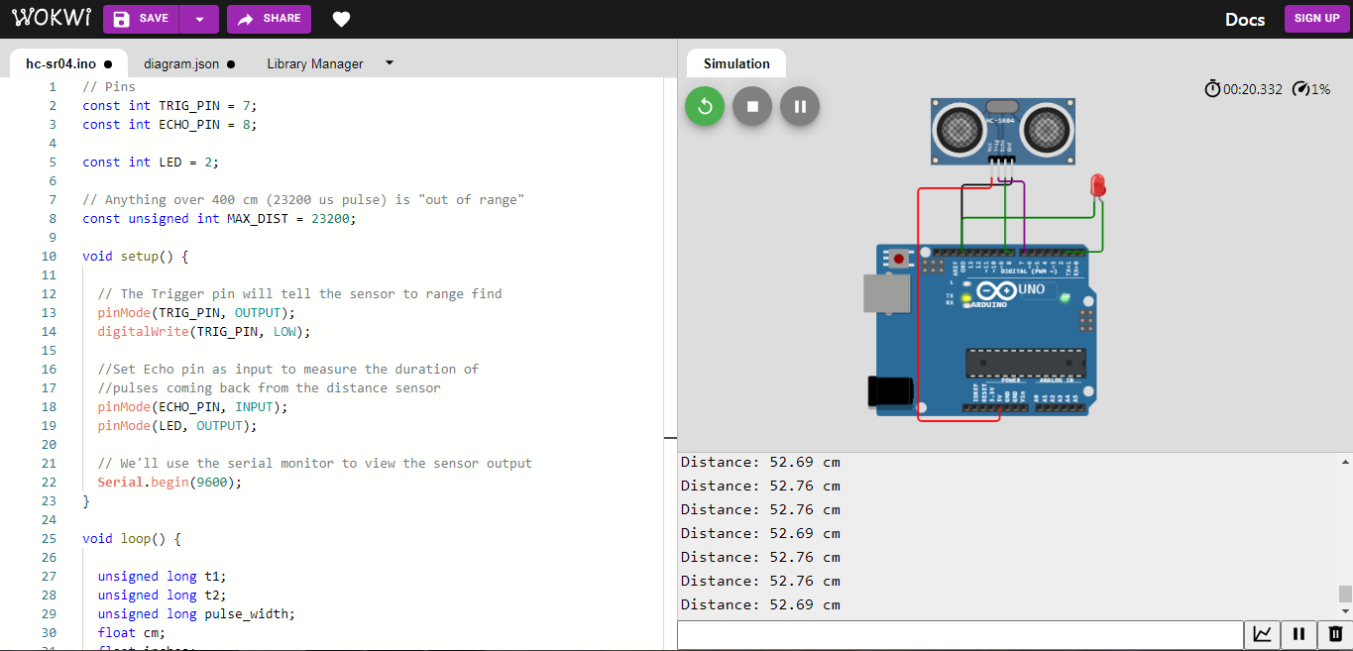

**Case (ii) : Distance > 100cm**

